**Assignment -2**

Python Programming

|  |  |
| --- | --- |
| Assignment Date | 29 September 2022 |
| Team ID | PNT2022TMID44156 |
| Student Name | Rashidha Begam |
| Student Roll Number | 724019104018 |
| Maximum Marks | 2 Marks |

**Question-1:**

Write a Python program which accepts the radius of a circle from the user and compute the area.

|  |
| --- |
| **Solution:** |
| from math import pi  r = float(input ("Input the radius of the circle : "))  print ("The area of the circle with radius " + str(r) + " is: " + str(pi * r**2))  **Output:** |
|  |
|  |
|  |
|  |
|  |
|  |
|  |
|  |
| **1pro.JPG** |  |

**Question-2:**

Write a Python program to create a histogram from a given list of integers.

|  |
| --- |
| **Solution:** |
| def histogram( items ):  for n in items:  output = ''  times = n  while( times > 0 ):  output += '*'  times = times - 1  print(output)  histogram([2, 3, 6, 5])  **Output:** |
|  |
|  |
|  |
|  |
|  |
|  |
|  |
|  |

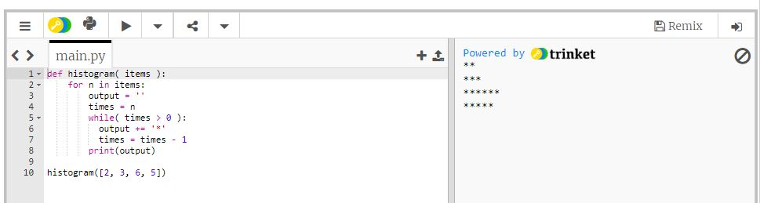

**Question-3:**

Write a Python program to compute the greatest common divisor (GCD) of two positive integers.

**Solution:**

def gcd(x, y):

gcd = 1

if x % y == 0:

return y

for k in range(int(y / 2), 0, -1):

if x % k == 0 and y % k == 0:

gcd = k

break

return gcd

print("GCD of 12 & 17 =",gcd(12, 17))

print("GCD of 4 & 6 =",gcd(4, 6))

print("GCD of 336 & 360 =",gcd(336, 360))

**Output:** 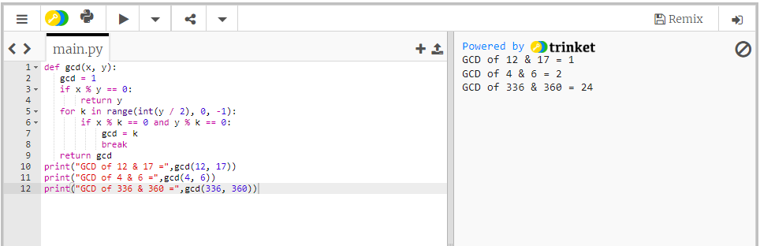

**Question-4:**

Write a Python program to display the first and last colors from the following list.

**Solution:**

color_list = ["Red","Green","White" ,"Black"]

print( "%s %s"%(color_list[0],color_list[-1]))

**Output:**

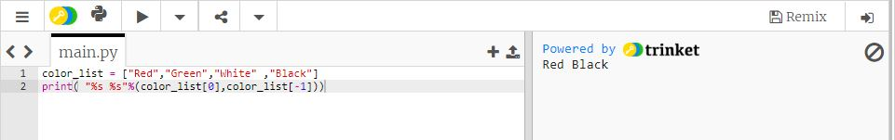

**Question-5:**

Write a Python program that accepts an integer (n) and computes the value of n+nn+nnn.

Sample of n is 5

**Solution:**

a = int(input("Input an integer : "))

n1 = int( "%s" % a )

n2 = int( "%s%s" % (a,a) )

n3 = int( "%s%s%s" % (a,a,a) )

print (n1+n2+n3)

**Output:**

